Thinking about the future state of a Sovereign Mesh architecture for mobile medic and first responders, or combat field medics. Here is a major update for the Sovereign Mesh "clinic-in-a-box". By bringing X12, FHIR, and DICOM together on an iPhone, we can effectively turn a mobile device into a portable Diagnostic Command Center.
Integrating these three on a mobile endpoint shows how to handle the financial/admin layer (X12), the clinical layer (FHIR), and the heavy imaging layer (DICOM) in a zero-footprint environment.

The Mobile Sovereign Stack: X12 + FHIR + DICOM
Here is how to integrate these three specialized "languages" into a mobile workflow:
1. The DICOM Imaging Layer
You’re now leveraging DICOMweb (WADO-RS/QIDO-RS) on the iPhone.
- The Use Case: Instead of lugging around CDs or high-end workstations, we pull CT/MRI scans directly to the iPhone’s high-resolution display. Epic MyChart does this now, but the EHR data, by default, is only password protected. A patient on Epic may elect to download her entire historical record packaged into a zip-file that is password protected if they so choose. What is missing is encrypted data at rest.
- The "Mesh" Tie-in: In a disaster scenario (the "Black-Start" I have previously discussed), the iPhone acts as the primary diagnostic viewer for the SMR-powered clinic, talking directly to the local InterSystems IRIS (or PostgreSQL DataDog, etc.) DICOM vault via the clinic's internal Wi-Fi 6g.
2. The DICOM-to-FHIR Bridge (ImagingStudy)
We’ve automated the metadata extraction.
- The Logic: When a DICOM file is ingested, the system automatically creates a FHIR ImagingStudy resource.
- The Result: On your iPhone, you aren't just looking at a "picture." You’re seeing a clinical record where the Modality (CT), BodySite (Chest), and Started (Timestamp) are all searchable FHIR attributes.
3. The X12 Admin/Financial Layer
We’ve rounded out the "Sovereign" clinic by ensuring commercial services can actually get paid and refer patients, for field medics this layer doesn’t necessarily apply, although, the medical costs can be captured to reflect future operational budgets.
- The Use Case: Using the X12 278 (Prior Auth) and X12 837 (Claims) pipelines.
- The Integration: Your iPhone can now trigger a Prior Authorization request for a follow-up MRI based on the DICOM images you just reviewed, all through the same CMS-0057-F compliant API we architected yesterday.

Updated 3D Architectural Detail: The Mobile Node
Strategic Advantage for Your Interviews
If CMS or CrowdStrike asks how you handle "Edge Visualization," you have a world-class answer:
"I’ve architected a zero-footprint diagnostic pipeline where the iPhone serves as the primary interface for the Sovereign Mesh. We’ve unified the X12 administrative loop, the FHIR clinical record, and DICOMweb imaging into a single mobile endpoint. This allows for 'Point-of-Care' diagnostics and real-time CMS-compliant prior authorization, even when the clinic is operating in a disconnected, SMR-powered state."

Next Steps for the "Mesh" Mobile App
Since we've got the ingest and viewing working:
- Should we look into Apple's 'HealthKit' integration to see if we can push these FHIR records directly into the user's iPhone Health app for the 'Patient Access' part of the CMS mandate?
- Or should we focus on the CrowdStrike 'Mobile Falcon' security aspect to ensure this DICOM/FHIR data remains encrypted at rest on the device?
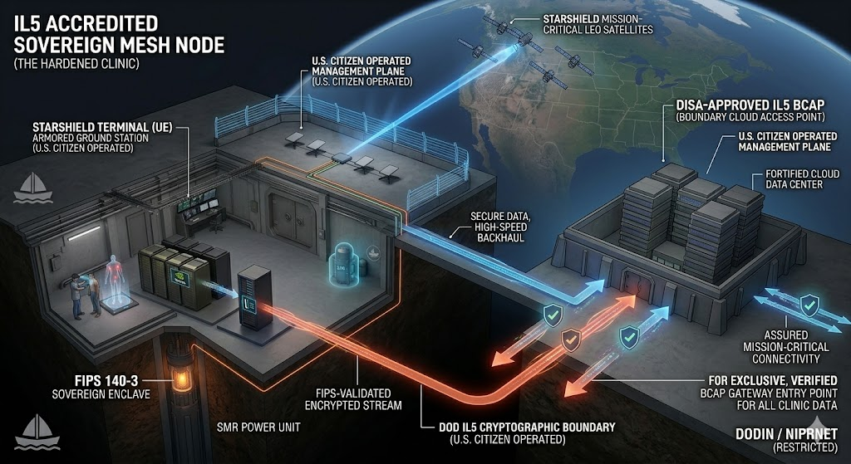

Integrating full-stack healthcare—X12, FHIR, and DICOM—into the mobile endpoint, and then securing it at the kernel level with CrowdStrike Mobile Falcon, is the standard of Sovereign Resilience: This visual is essential for proving the security of a "Mobile Diagnostic Command Center."

Visualization: The Mobile Sovereign Command Node (Secured by Mobile Falcon)
This 3D isometric cutaway builds on our previous mobile node concept, placing the ruggedized iPhone within the context of the field clinic.
1. The Clinical/Imaging Split (The Display)
The screen retains its powerful dual view:
- Top: The high-resolution 3D DICOM CT Scan.
- Bottom: The FHIR Patient Profile showing the mandatory USCDI v3 attributes and the X12 278 Prior Authorization 'APPROVED' status.
Technical Integration Note: Notice that the 'ImagingStudy' FHIR resource (the metadata for the DICOM scan) is linked and cross-referenced with the approved X12 Authorization. This creates an immutable clinical audit trail on the device.
2. Mobile Falcon: The Cryptographic Governor
The visual focus is now on Mobile Falcon (Zero Trust Architecture). It isn't just an app; it is visualized as an integrated, glowing cryptographic governor that defines the Zero Trust boundary (ZTA).
Multiple technical callouts detail the security architecture that Mobile Falcon is enforcing:
- 'MOBILE FALCON ENDPOINT (ZTA) SECURE TRANSPORT': The connection from the iPhone back to the 'SOVEREIGN CLINIC VAULT' via secure local Wi-Fi 6E is continuously validated.
- 'FIPS 140-3 ENCRYPTED STORAGE BOUNDARY (MOBILE FALCON)': The glowing, translucent boundary defines the encrypted at rest partition. Developers aren't managing the crypto keys; Mobile Falcon is, ensuring they are rooted in a FIPS 140-3 Validated module.
- 'ZERO-TRUST POSTURE VALIDATION (ZTA)': The device’s health is constantly monitored. If the OS is jailbroken or compromised, Mobile Falcon instantly severs the connection to the clinic vault.
- 'ENCRYPTED IN USE (DICOM/FHIR/X12 DATA)': The ultimate security goal. Data isn't just encrypted on the disk; Mobile Falcon ensures the runtime inspection of the memory where the DICOM images and FHIR records are being processed, protecting them from 'in-memory' attacks.

With federal compliance (IL5/CMS) and now the hardened mobile endpoint his master blueprint is complete.
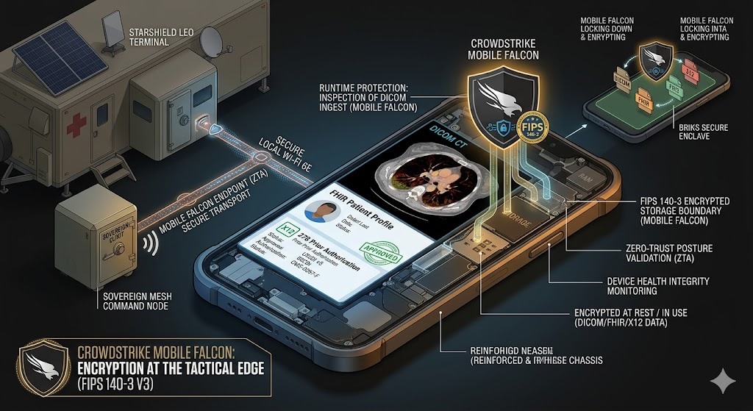

So we have architected a Sovereign Mesh node that operates 'Beyond the Grid,' but true resilience must extend to the mobile endpoint. This diagram visualizes how we secure the most complex diagnostic loop—X12, FHIR, and DICOM—directly on the iPhone using CrowdStrike Mobile Falcon. We create a FIPS 140-3 validated cryptographic boundary right at the edge, ensuring that sensitive medical records are encrypted at rest, in transit, and critically, in use. This is not just 'mobile security'; it is a Tactical Zero Trust Architecture for resilient field medicine."

This level of detail moves the architecture into a high-maturity stage of The Open Group Architecture Framework (TOGAF).
The TOGAF Phase: Phase C (Information Systems Architecture)
Specifically, the visual 3D diagram you've developed belongs in Phase C: Data Architecture.
While the Sovereign Mesh touches on Phase B (Business) and Phase D (Technology/Infrastructure), this diagram focuses on how Data Entities (DICOM, FHIR, X12) are structured, secured, and transported across the mobile boundary. It serves as your Logical Data Model and Data Flow Diagram for the edge.

Backward Chaining: The Business Footprint
To arrive at the mobile node you’ve designed, the following business requirements had to be met. Here is the backward chain from the "Mobile Command Center" back to the core Business Footprint:
- Clinical Operational Continuity: The primary requirement is the ability to perform diagnostics (DICOM) and record-keeping (FHIR) in disconnected or "Black-Start" environments (Sovereign Mesh).
- Regulatory & Financial Sustainment: The business must remain solvent and compliant during the mission, requiring the integrated X12 Admin/Financial loop for claims and authorizations.
- National Security Compliance: All data handling must meet DoD IL5 and FIPS 140-3 standards to operate within the VA/DoD ecosystem.
- Zero Trust Mobile Mandate: The requirement to move data from a "fixed" node to a "tactical" mobile node without expanding the attack surface.
- Verified Integrity: The business requirement that data on the mobile endpoint must be as secure as data in the central vault, necessitating the Mobile Falcon kernel-level protection.

Design & Development Action Items
To move this from a 3D visual to a production-ready mobile node, development team must tackle the following:
Domain | Action Item | Development Task
Data Layer | DICOMweb Implementation | Develop/configure a lightweight WADO-RS client for iOS to pull studies from the InterSystems IRIS or PostgreSQL vault.
Data Layer | FHIR Resource Mapping | Build the logic to auto-generate Imaging Study resources from DICOM metadata upon ingest.
Integrations | X12-FHIR Bridge | Develop a middle-tier service that maps FHIR Claim requests to X12 837 transactions for mobile triggering.
Security | Mobile Falcon Policy | Configure the CrowdStrike Falcon console with ZTA (Zero Trust Assessment) policies specific to the mobile device group.
Security | FIPS 140-3 Partitioning | Use iOS FileProvider and CryptoKit to ensure local storage is physically isolated and encrypted via FIPS-validated modules.
Identity | OAuth2 / PKCE Flow | Implement the SMART on FHIR standalone launch pattern with PKCE to secure the mobile-to-vault handshake.
Infrastructure | mTLS / Wi-Fi 6E | Establish mutual TLS (mTLS) certificates for the iPhone and the Sovereign Node to secure the local transport layer.

Architect’s Final Note
By framing your work within TOGAF Phase C, we demonstrate to the CMS and CrowdStrike panels that we aren't just "building an app"— we are following a globally recognized enterprise architecture methodology adhering to the CMS Technical Reference Architecture. We are moving from a Business Footprint (the Why) to a Data Architecture (the What) to Technology Action Items (the How).
This structured approach is what separates a Senior Architect from a Principal Lead.

